Build A Employee Travel Approval Application For Corporate

INTRODUCTION

* 1. Overview

Corporate travel is an integral part of the business world, as companies need to travel to meet clients, attend conferences and meetings, and explore new markets. However, managing employee travel can be a cumbersome task for the HR and travel departments. That’s why many corporates have started using employee travel approval applications to streamline the process

* 1. Purpose

The application saves time for both the employee and the travel request and approval process. The application ensures that travel requests comply with the company’s travel policies, expenses and unnecessary travel.

PROBLEM DEFINITION AND DESIGN THINKING

2.1 Empathy Map

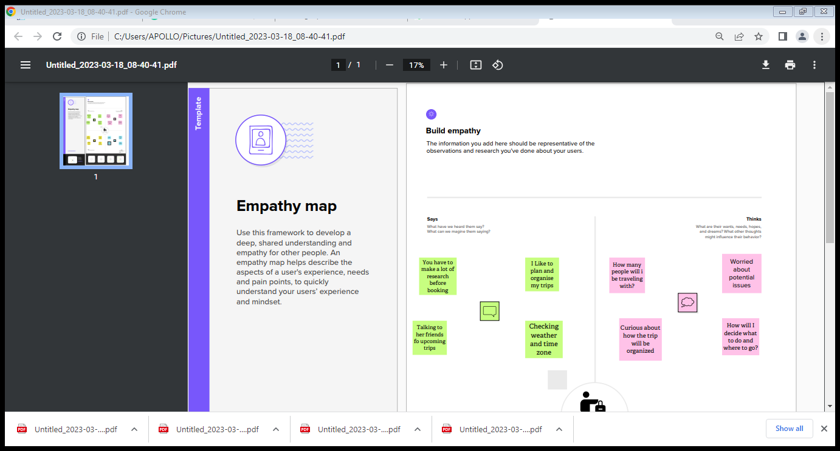

2.2 Ideation And Brainstroming Map

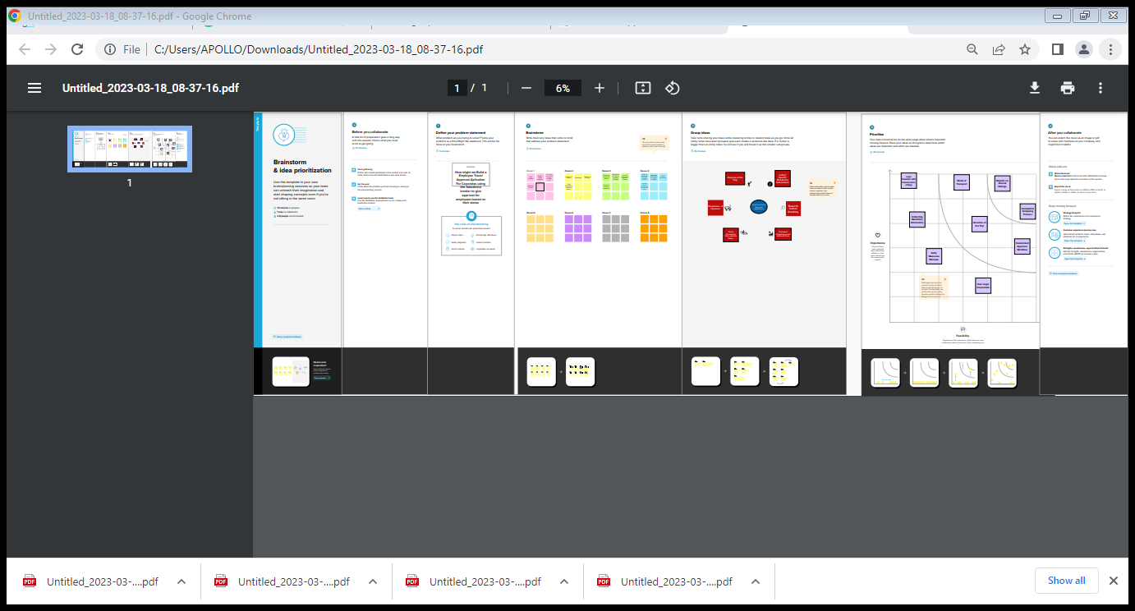

RESULT

3.1 Data Model

|  |  |
| --- | --- |
| Object Name | Fields in the Object |
| Object 1  TRAVEL APPROVAL | |  |  | | --- | --- | | Field Label | Data Type | | Total  Expenses | Roll-up  summary | |
| Object 2  CONTRACT | |  |  | | --- | --- | | Field Label | Data Type | | Days  Remaining | Formula | |

3.2 Activity And Screenshot

Creating The Application

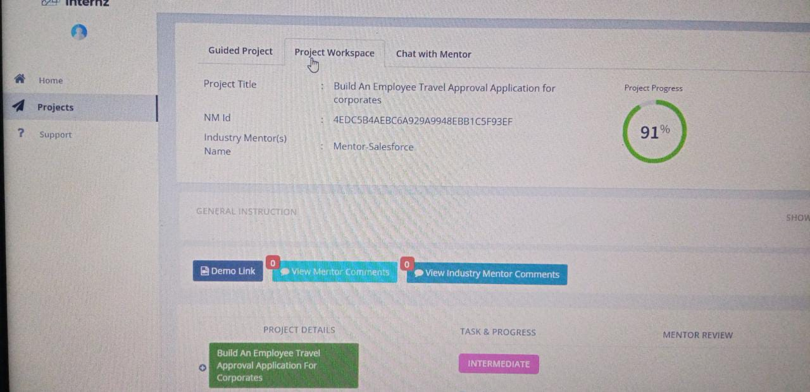

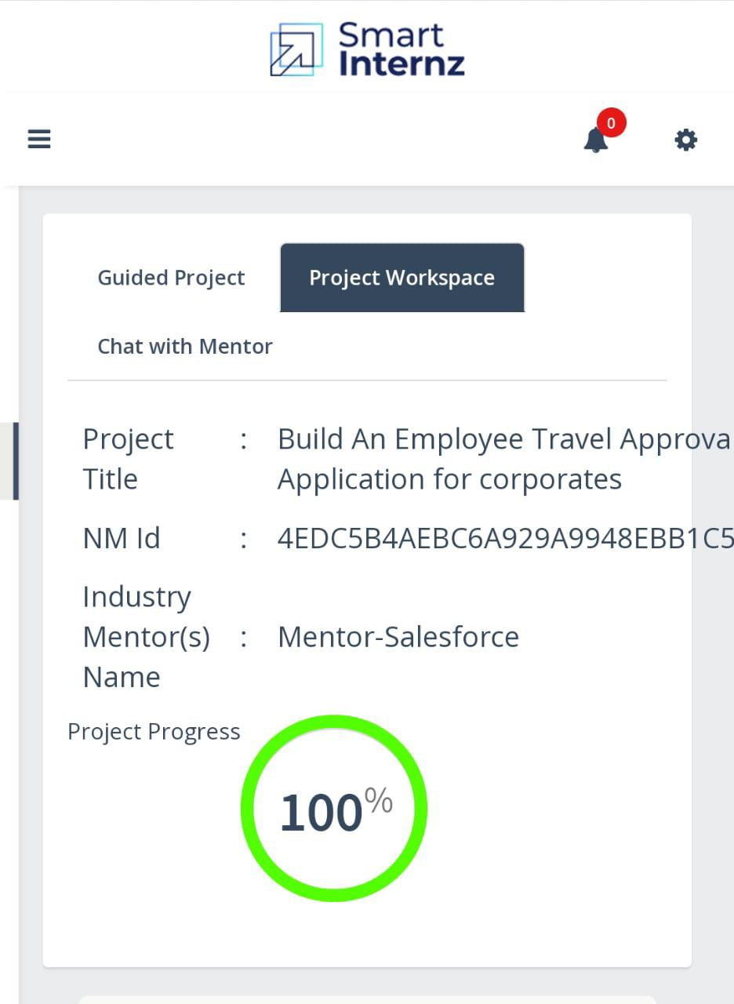

Trailhead Profile Public URL

Team Leader: <https://trailblazer.me/id/dsridhar19>

Team Member 1: <https://trailblazer.me/id/deepr69>

Team Member 2: <https://trailblazer.me/id/bgirija2>

Team Member 3: <https://trailblazer.me/id/gayae7>

4 ADVANTAGES AND DISADVANTAGES

4.1 Advantages:

* The process is tedious and time consuming task
* Easiest way
* Saves time for both employees and managers
* Reduces the workload
* The entire process is digitized and streamlined
* Increased Transparency
* Provides greater control and security over employee travel

4.2 Disadvantages:

* The process includes too many levels of approval that make tedious and confusing
* Regular Maintenance
* Internet Connection leads to trouble and anxiety
* Lack of leadership
* It can be costly sometimes

5 APPLICATION

The application ensures that travel requests comply with the company’s travel policies which reduce the risk of non-complaint expenses and unnecessary travel.

The application saves time for both the employee and the travel manager by automating the travel request and approval process. This allows the HR department and travel managers to focus on more strategic tasks.

6 CONCLUSION

An employee travel approval application is a valuable tool for corporate travel management

A Well-Designed application can save time and money, making it an essential tool for corporate that frequently travel for business.

7 FUTURE SCOPE

* In future it will be really a useful one in the application of travel approval.
* It is trusted to be in future everyone will utilize this.
* The customer will set good service and make it trustworthy.
* Hope it would fulfill all the needs of the users.